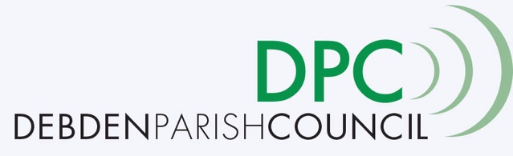
March 4th 2020

Public Consultation on Council Tax Precept Increase

Frequently Asked Questions
Q Why is a council tax precept increase being proposed?
A The MoD, who generously gave the new village hall project a Community Covenant grant of £236,400, have stipulated that unless we can evidence by the end of March that the full funding is in place for the new village hall project, then the grant will be withdrawn without exception. The only way to achieve this in the time frame is for the Parish Council to make provision to be able to underwrite the current funding gap. It is not unusual for Parish or County Councils to secure loans in this way.

Q Why is there only one village hall option being pursued by the Village Hall Trust?
A The Village Hall Trust, whose responsibility it is to provide a village hall, only has full visibility of one scheme at the present time. This plan is the result of extensive public consultation and the mediation agreement between the key stakeholders (Debden Parish Council, The Recreation Ground Trust, The Village Hall Trust and The New Village Hall Group), overseen by the MoD and UDC. Please speak to the Village Hall Trustees for further information on the hall proposals.

Q Why is the pavilion being replaced?
A The proposed siting of the village hall is the result of the mediation agreement. Currently the pavilion is only usable by the football team. A new pavilion will open the recreation ground to a wider group of users. The Parish Council has formed a working group to see the pavilion project through to completion and planning permission will be submitted shortly. The new hall and pavilion will result in much needed regeneration of the whole Recreation Ground.

Q How much will my council tax precept increase?
A Although provision for a borrowing mechanism of up to £400,000 would be put in place, it is highly unlikely that this maximum amount would be needed as it assumes no further funding or cost savings are secured for the project. The amount the precept could increase is dependent on how much of the loan the Parish Council is required to draw down. See below for illustrative examples of council tax precept increases for an average Band D property based on different borrowing scenarios*:
- Based on £100,000 borrowed: precept increase of £11.21 per year
- Based on £200,000 borrowed: precept increase of £22.43 per year
- Based on £300,000 borrowed: precept increase of £33.64 per year
- Based on £400,000 borrowed: precept increase of £44.85 per year
*This is based on the current prevailing interest rate set by the PWLB which may change.

Q When would my council tax precept increase?
A Funds would only be drawn down if and when needed . Any council tax precept increase would not come into effect before financial year 2021/22.

Q How do I cast my vote?
A You can cast your single vote at either of the 3 public consultation meetings, online via Survey Monkey or by post to the address provided at UDC. Any votes received by other means will not be counted.

Q Who can vote?
A Any resident of the Parish of Debden or Debden Green, over the age of 18 and registered on the electoral roll is eligible to vote.

Q When does the consultation close?
A On March 20th 2020 at midnight. Any votes received after this time will not be counted.

Q How is the process being overseen and scrutinised?
A Votes cast at the public consultation meetings will be stored in a sealed ballot box. Votes cast via Survey Monkey will be collated at the end of the consultation period. Votes sent by post to UDC will be logged and placed, unopened, into a sealed ballot box until the end of the consultation period.
At the end of the consultation period, the Parish Council, together with an independent observer from UDC will:
- Collate all results onto a master document
- Eligibility to vote will be checked against the electoral roll
- Any duplicates will be discarded
- Votes for and against will be counted and verified
- A simple majority for or against will be recorded.

